The Total Vaccinations across the North America Regions
(United States vs Canada)

By: Panic! At the Costco
Muhammad Adlan Arif bin Mohd Ezman 02356253
Aishwinie Pillai 12910260
Savyeli Yavorovskiy 66582529
Janice Shu Lin Chng 35107737

Executive Summary

COVID-19 is a deadly virus that has been around since December 2019, and the only way to reduce the spread of infections is by having more individuals vaccinated. Vaccination allows individuals to build immunity and protect themselves from serious infections and further complications caused by the virus. Despite the fact that no vaccine is 100% effective, all the existing vaccines have an efficacy rate ranging from 62% all the way up to 90%.

We are studying the rate of vaccinations in the United States and Canada to forecast and analyze the rate of vaccinations thus far versus the predicted forecast of the population that will be vaccinated in the upcoming years. With this information, we will be able to learn the country’s rate of approaching herd immunity and minimizing the spread of the virus.

In our regression analysis, we wanted to know what variables good predictors will be to forecast the number of vaccinations in the United States and Canada. To obtain the final model, we used backwards stepwise model comparison to determine which variables to include in the final model. To test if our final model is usable, we also used the final model to forecast and compared it to the actual data from the dataset.

In our time series analysis, we segregated the data individually in order to have a clear approach towards the individual country’s vaccination rate. We observed the time series plot before and after the adjustment of the beginning of the total vaccination for each country. After that, we had a look at the ACF and PACF plot to see the pattern and checked the stationarity of each model. We then fit the models according to their appropriate (p,d,q) model and do the model diagnostics on the residuals as the last step before forecasting.

To summarize the difference between the regression and time series models, we made a comparison and specified any significant observation that can be seen and ended our research with a conclusion and recommendation.

1.0) Motivation and Introduction of the Problem

In December 2019, Coronavirus (COVID-19) cases began to emerge in Wuhan, China. COVID-19 is an infectious respiratory disease that can be transmitted quickly from person-to-person. Consequently, cases of COVID-19 broke out worldwide, resulting in a global pandemic that continues to impact our lives today. Symptoms can range from mild symptoms to severe illnesses resulting in hospitalization, making it important for people to take precautionary measures.

In 2020, COVID-19 vaccine production began with the goal of limiting the spread and impact of the virus. There were many countries and industries that took interest in developing a vaccine against the deadly virus and the efficacy rate for the existing vaccines ranged from 62% to 90%. Vaccines can grant immunity or protection from COVID-19 for those who choose to take them, making the total number of vaccinations a useful measure of protection against the virus in different parts of the world.

By looking at vaccination rates, we look to answer the following questions:
- What factors significantly impact vaccination rates?
- What is the vaccination progress in Canada and the United States?
- What does the forecasted number of vaccinations look like?

To answer these questions, we used the “COVID-19 World Vaccination Progress Data” dataset that was published on Kaggle. The data was collected from “Our World in Data,” which is an online scientific publication that provides the most comprehensive information on vaccinations, by country, worldwide.

Because the dataset contains a significant amount of information for over 100 countries, we decided to focus on North America, specifically the United States and Canada, and so we filtered some parts of the dataset. We did this to simplify the analysis and interpretation of our models.

Description of Data

More details and source of the dataset can be found below:

- (Source of data)
https://www.kaggle.com/fedesoriano/coronavirus-covid19-vaccinations-data?select=owid-covid-data.csv

- (Explanation on each variable)
continent | Continent of the geographical location
location | Geographical location
date | Date of the observation
total_cases | Total confirmed number of Covid-19 cases
total_deaths | Total number of deaths attributed to Covid-19
reproduction_rate | Real-time estimate of the effective reproduction rate of Covid-19
icu_patients | Number of Covid-19 patients in intensive care units (ICUs) on a given day
hosp_patients | Number of Covid-19 patients in the hospital on a given day
total_tests | Total number of tests for Covid-19
positive_rate | Share of Covid-19 tests that are positive
total_vaccinations | Number of Covid-19 vaccination doses administered
stringency_index | Composite measure based on 9 response indicators including school closures, workplace closures, and travel bans, rescaled to a value from 0 to 100 (100 = strictest response)
population | Location’s population in 2020
population_density | Number of people divided by land area, measured in square kilometers
median_age | Median age of the population
aged_65_older | Share of the population that is 65 years and older
gdp_per_capita | Gross domestic product at purchasing power parity (constant 2011 international dollars)
extreme_poverty | Share of the population living in extreme poverty
diabetes_prevalence | Diabetes prevalence (% of population aged 20 to 79)
female_smokers | Share of women who smoke
male_smokers | Share of men who smoke
life_expectancy | Life expectancy at birth

2.0) Regression Model
For regression, we will be using total_vaccination variable as our response (Y) while the explanatory variables (X’s) will be the total_cases, total_deaths, reproduction_rate, icu_patients, hosp_patients, total_tests, positive_rate, stringency_index, population, population_density, median_age, aged_65_older, gdp_per_capita, extreme_poverty, cardiovasc_death_rate, diabetes_prevalence, female_smokers, male_smokers, handwashing_facilities, and life_expectancy variables

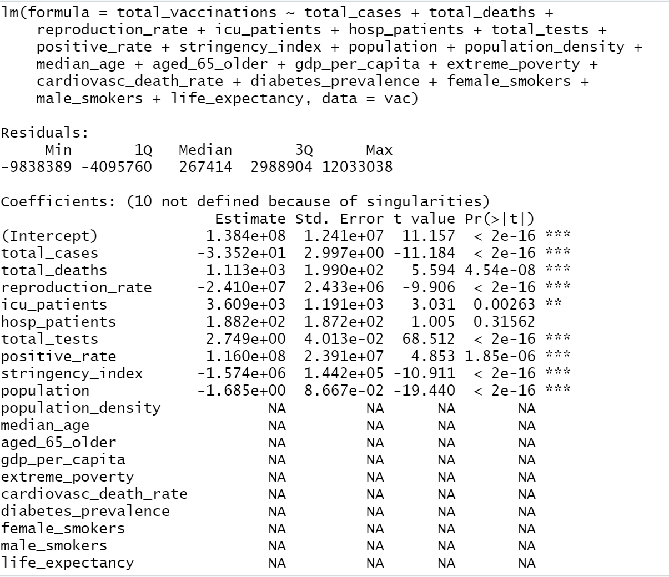

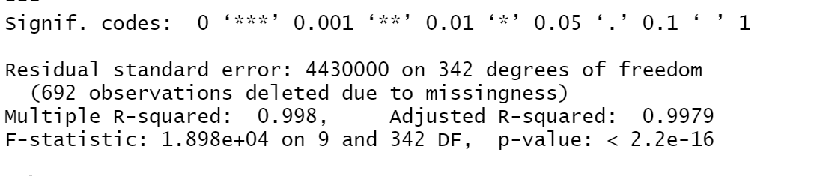
Exhibit 2.1: Summary of the multiple regression model with all variables included

As a consequence of using so many variables, this initial model is not a good fit and is difficult to interpret. It is notable that several variables do not return coefficients. Several “NA” values are present because many variables only had one value each for Canada and the United States, which does not result in a coefficient in the model output.

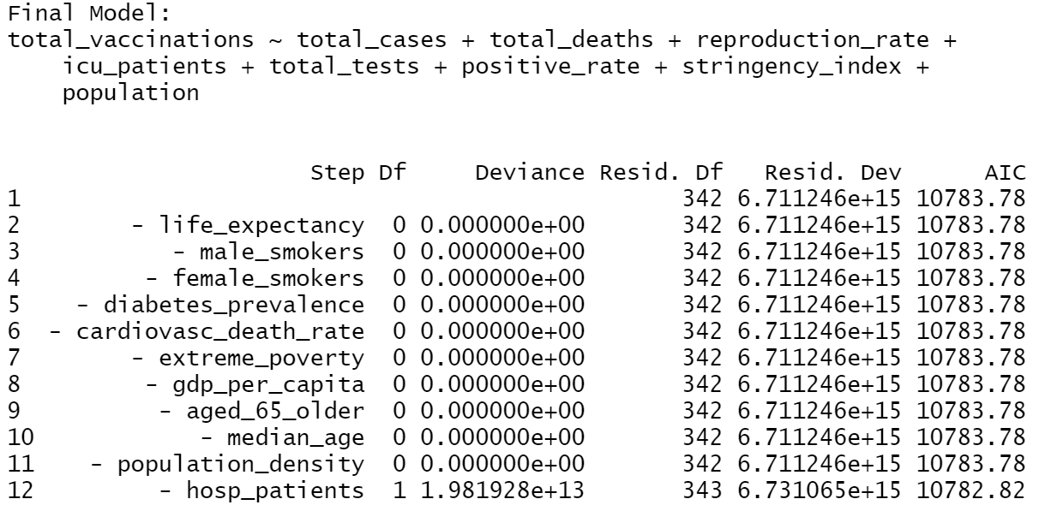
Exhibit 2.2: Final fitted model according to backwards stepwise model comparison

Exhibit 2.2 shows the final fitted model, which was determined through backwards stepwise model comparison. The final model removed several insignificant variables to obtain the lowest AIC score, which indicates that it is the best model. This model narrows down nineteen explanatory variables to just eight, making this model much easier to understand and interpret compared to Exhibit 2.1. The variable coefficients are presented in the table below.

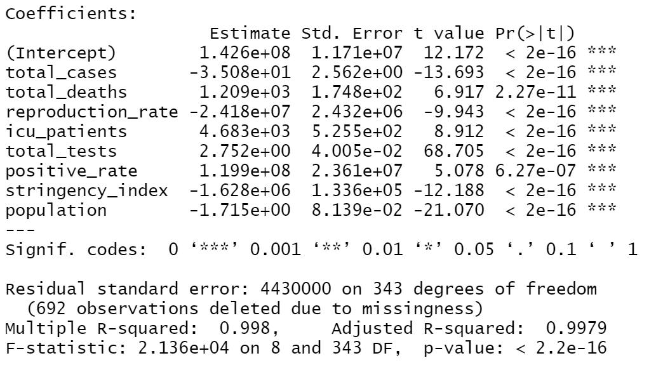
Exhibit 2.2.1: Details of the final model variables

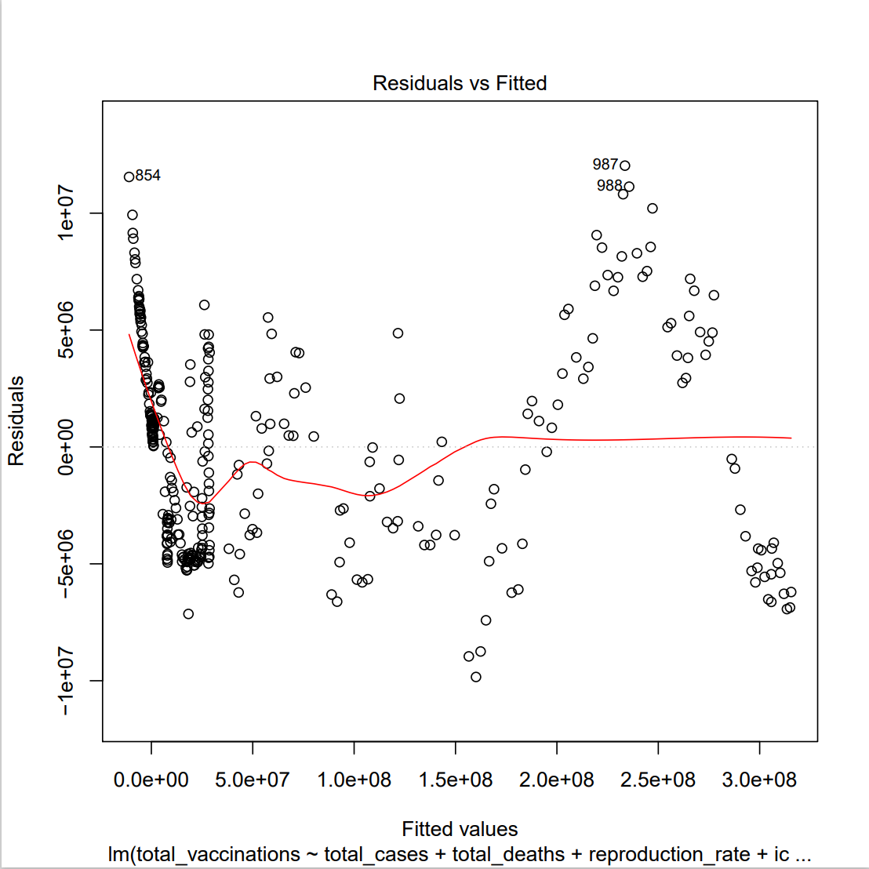
Exhibit 2.3.1, the first regression diagnostic plot, graphs residuals versus fitted values.

The red line shows the average value of the residuals at each fitted value. This diagnostic plot shows if the residuals have a linear or non-linear pattern, and if the data is modeled well by a linear relationship.

We see that the red line is not approximately zero, or horizontal, as well as clusters of residuals that appear to have several upward and downward trends. This indicates that data does not appear to be modeled well by a linear relationship between total vaccinations and its respective explanatory variables.
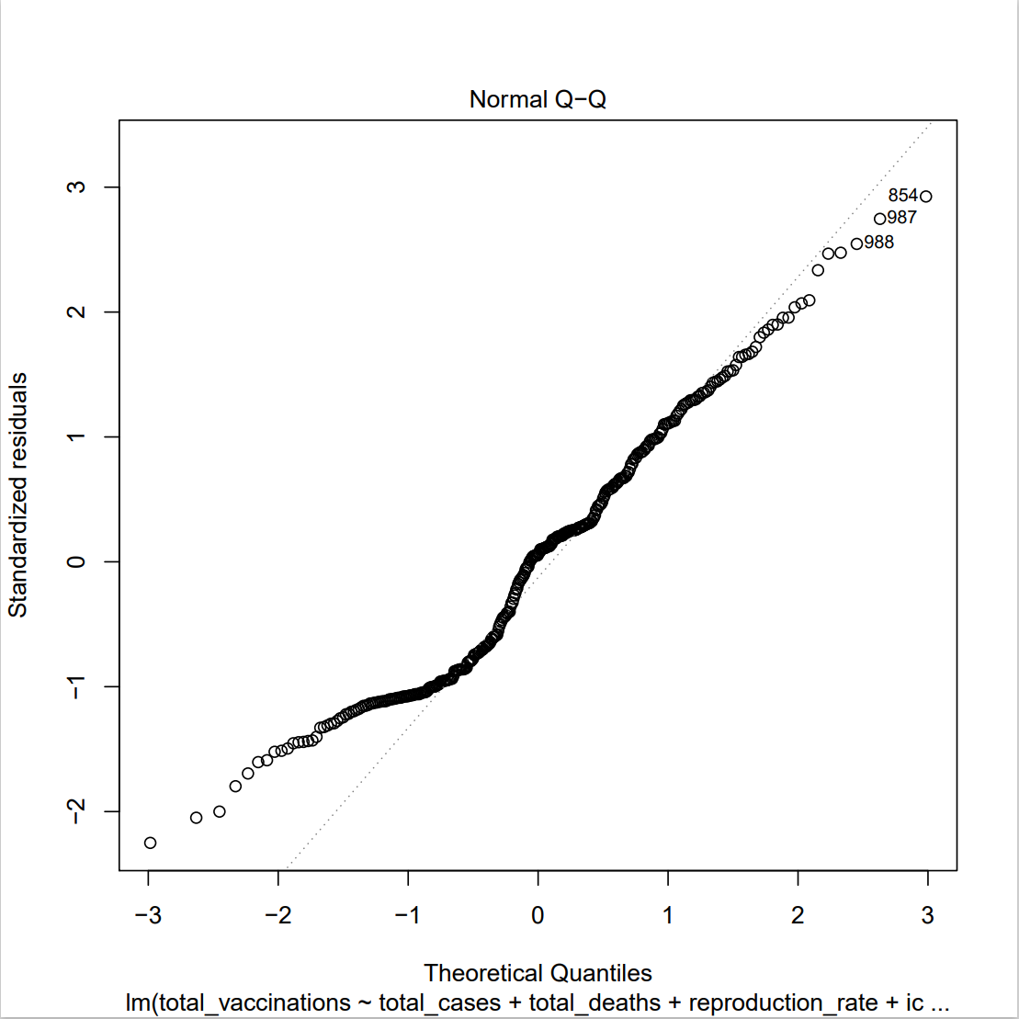
Exhibit 2.3.2, the second diagnostic plot, is a Normal QQ plot for assessing the normality assumption.
If the plotted residuals follow a straight diagonal line, we can conclude that the residuals are normally distributed.
The exhibit shows heavy-tailed residuals deviating from the diagonal line, indicating that the residuals are not normally distributed.

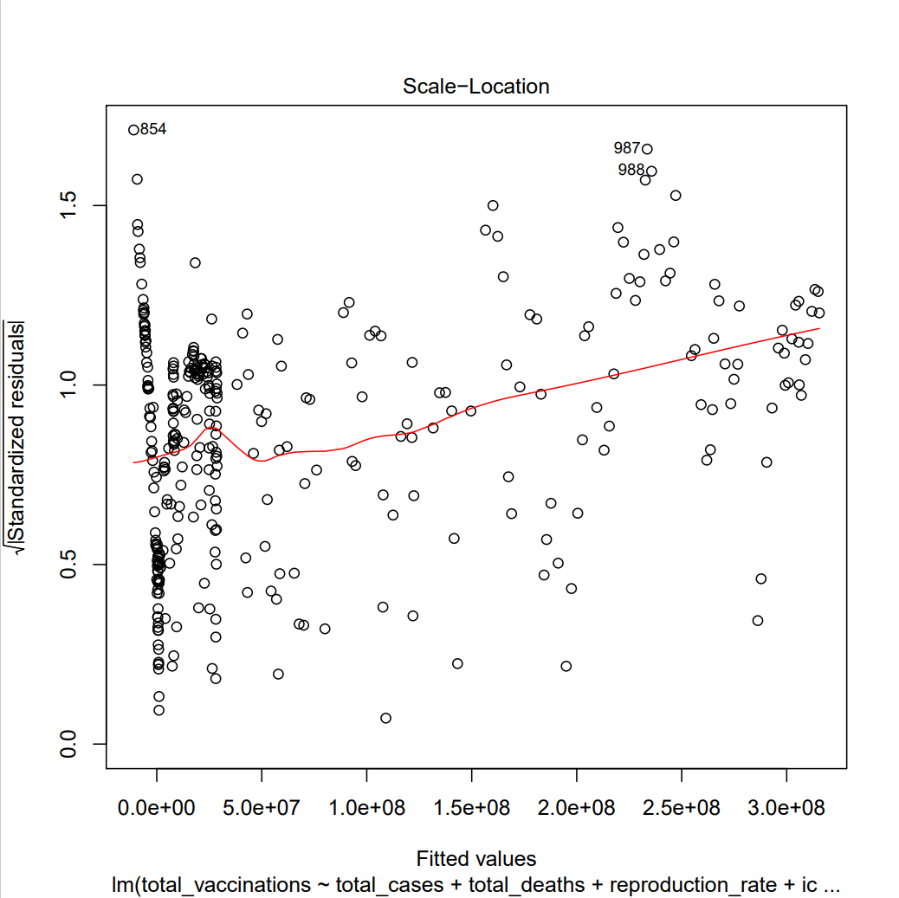
Exhibit 2.3.3, the scale-location plot

The plot tests the homogeneity of variance assumption. If the variance is constant, the residuals will be equally spread, and the red line will be horizontal.

Looking at the plot, we can see an upward trend in the red line, as well as unevenly spaced residuals. This suggests heteroscedasticity, or non-constant variances in the residuals errors, is present.

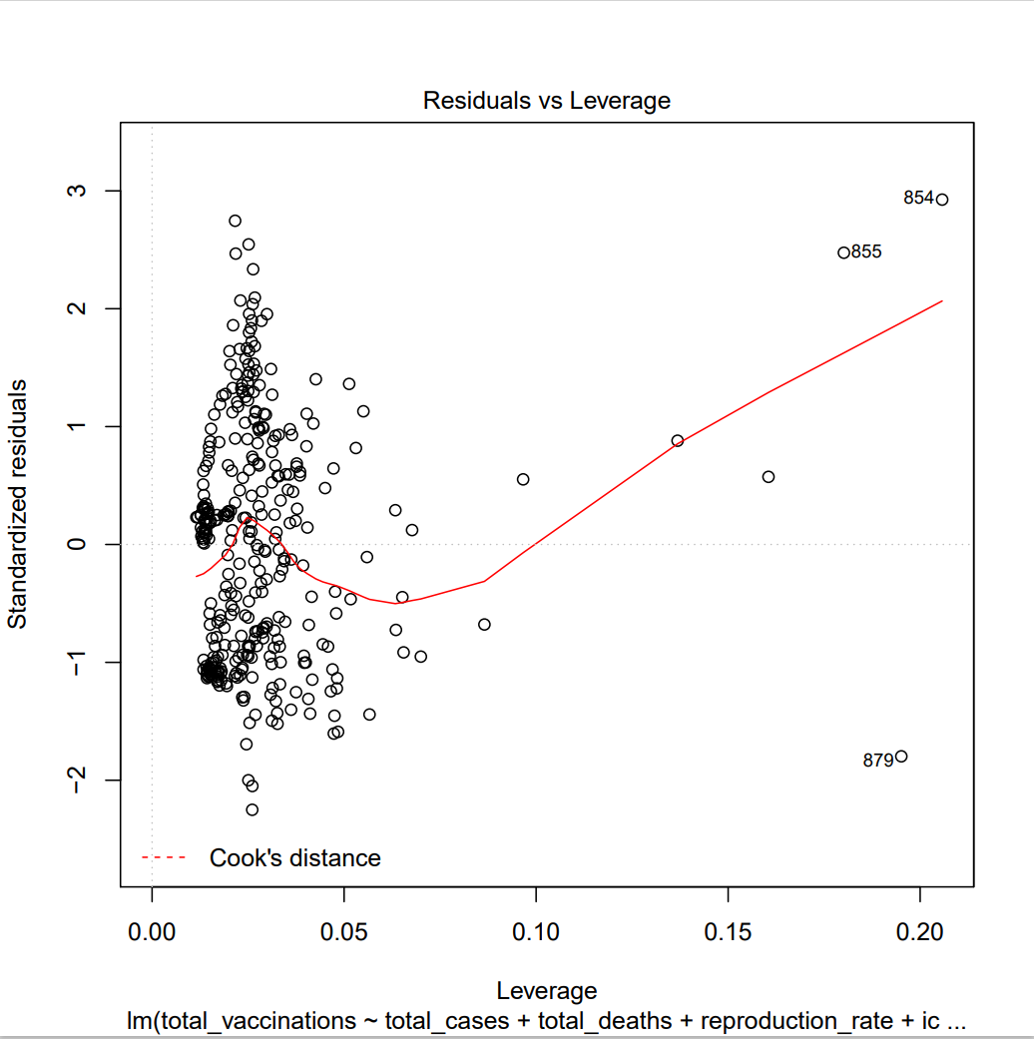
Exhibit 2.3.4: Residuals vs. leverage plot of the final model

The final diagnostic plot is a residuals vs. leverage plot. It identifies influential observations that can affect the interpretation of the model. If an influential observation is present, it will fall outside of Cook’s distance, the metric indicated in the legend.

By observing this plot, we see that there are no influential observations because the bounds for Cook’s distance do not appear. This shows that no observations need to be removed or investigated, as none of them would significantly impact the model if excluded.

Forecasting

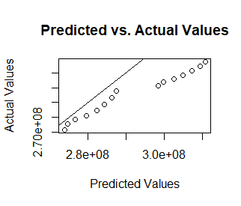

Exhibit 2.3.5 Graph comparison between actual and predicted number of vaccinations
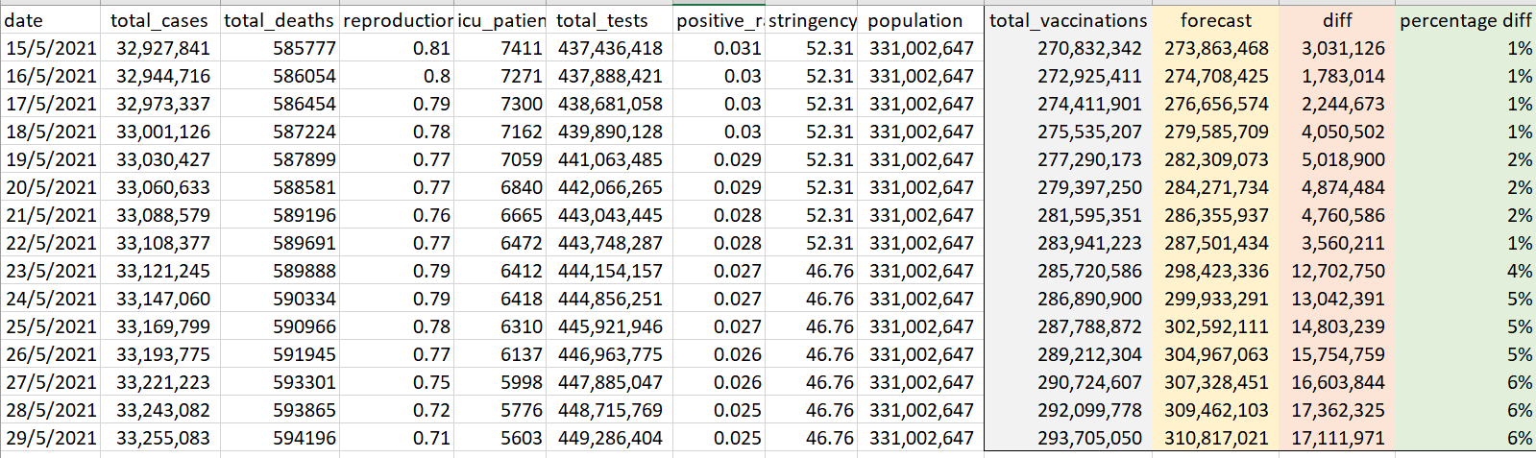
Exhibits 2.3.6 Table comparison between actual and predicted number of vaccinations

Once we obtained the final model, we were interested to know how well it is able to forecast the total number of vaccinations. Since the model requires a lot of variables, it would be difficult to obtain functional/ new data that has all these variables for forecasting. Hence, we used the last 15 rows of the data to see how accurate our final model is. According to the graph, the difference between the forecasted and actual results increases as the (data gets further away). From the table, it is observed that the forecasted results are overestimated. This might be due to the slowing down of vaccinations after more people have taken it.

3.0) Time Series

For Time Series, we will be using the total_vaccinations variable as our response (Y) and there is no frequency stated in the R plot. But the observations are based on daily records.

3.1) Time Series plot

First, we subset the dataset into two categories, Canada and the United States. We can go ahead and take a look at the plot for both of them.
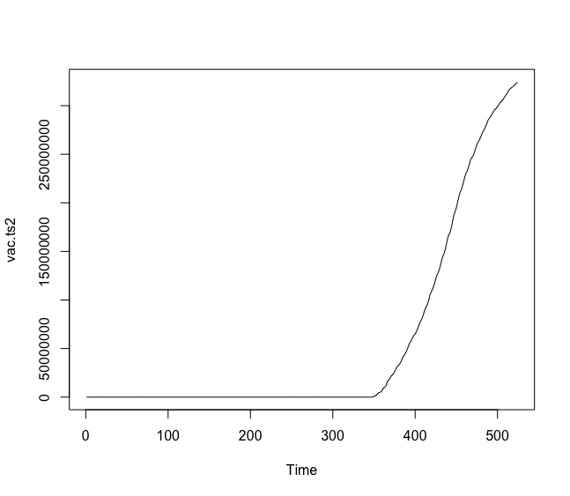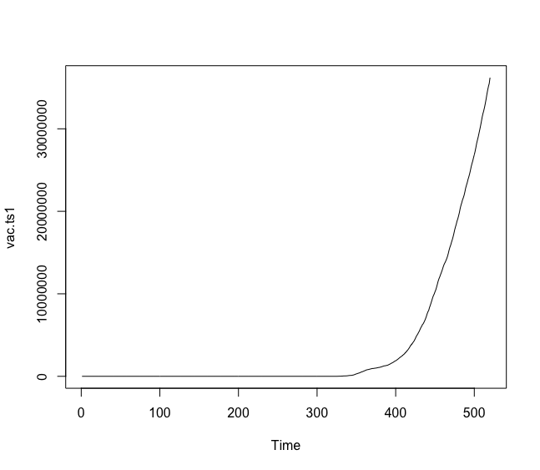
Exhibit 3.1 Canada time series plot Exhibit 3.2 United States time series plot

Both have similar graphs, but there seems to be a gap in between them; there are too many zeros in the early observations. It is probably due to the fact that approved vaccines became mass produced and distributed to the public towards the end of 2020 and early 2021. Therefore, these time series plot did not reflect their true observations. So, we adjust the plot and start with non-zero observations as the first observations for each country.

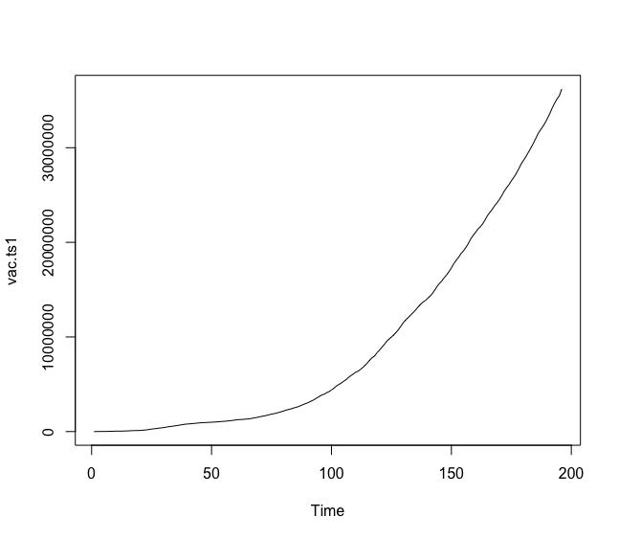
Exhibit 3.3 Canada time series plot (adjusted)
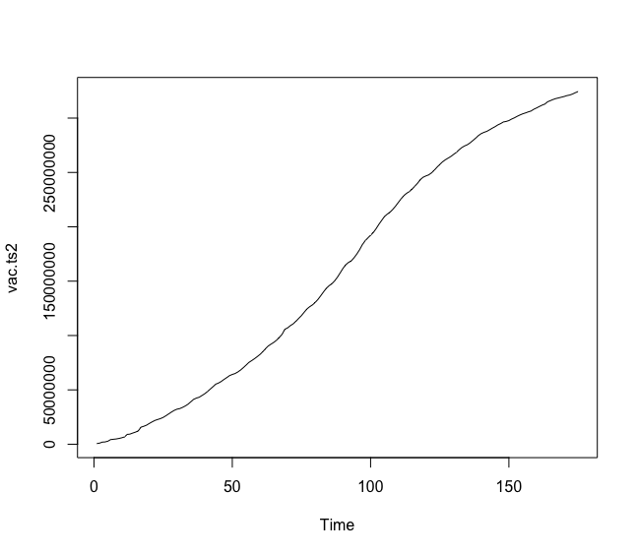
Exhibit 3.4 United States time series plot (adjusted)

After letting the 325th observation as Canada’s first observation and the 350th observation as the United States’ first observation, we obtained the above graphs. Canada has a graph in a quadratic form, while the United States has a similar graph, it seems to be approaching maximum. These observations are important as both are reaching their total populations of 37,742,157 and 331,002,647, respectively. These graphs show that the United States progressed much earlier than Canada did in terms of vaccinating their citizens. Next, we move on to their auto-correlation function (ACF) and partial auto-correlation function (PACF) plots.

3.2) ACF & PACF
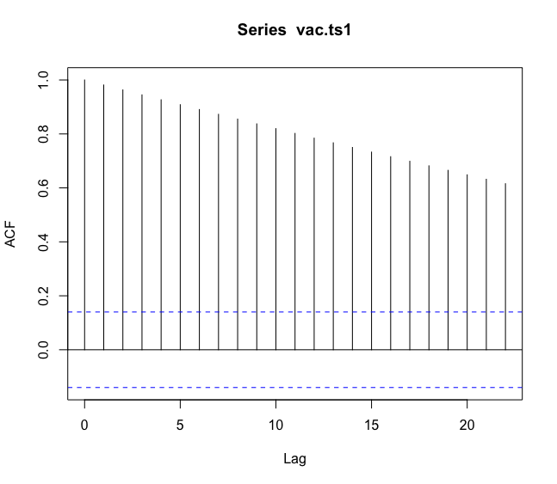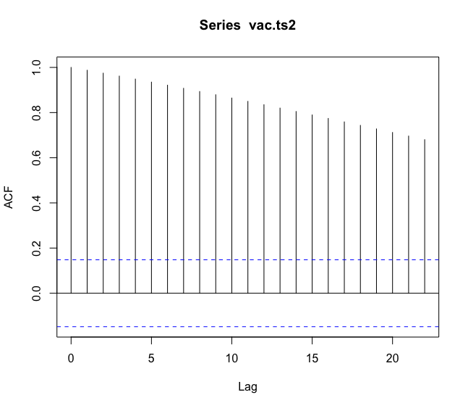
Exhibit 3.5 Canada’s ACF plot Exhibit 3.6 United States’ ACF plot
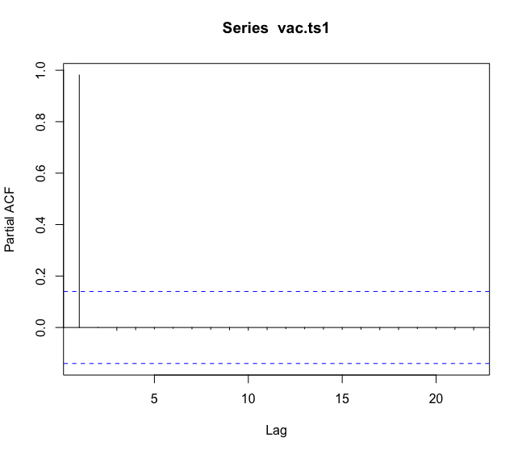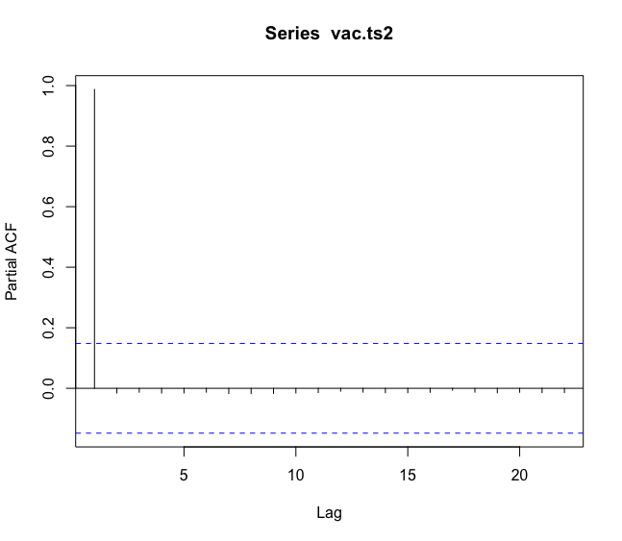
Exhibit 3.7 Canada’s PACF plot Exhibit 3.8 United States’ PACF plot

We can’t really observe anything from these plots, as the models might not yet be stationary. To test for stationarity, we can use the Augmented Dicker-Fuller test (adf.test) and assess the p-values for each of the graphs.

3.3) Stationary Test

- Canada
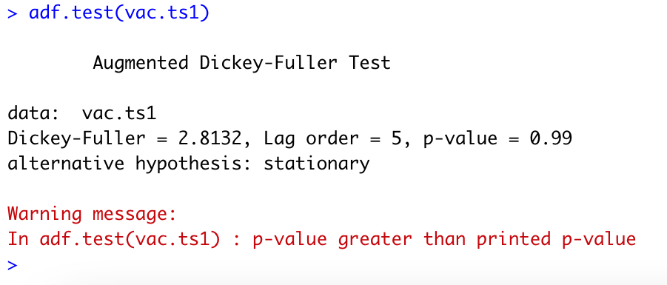
The R output on the left shows that the p-value > 0.05 which proves it is non-stationary.

Exhibit 3.9 adf.test on Canada

- United States
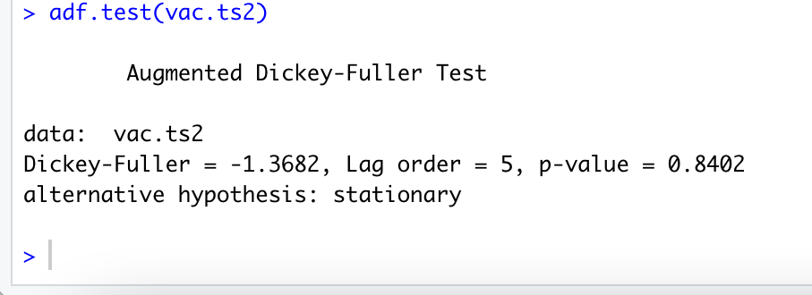
The R output on the left also shows that the model is non-stationary as the p-value is 0.8402 > 0.05

Exhibit 3.10 adf.test on United States

Given the circumstance where the p-value is higher than 0.05, we cannot predict a forecast. Both countries' models have been reported to be non-stationary. To move forward in this research, let us do the auto.arima function to find the (p,d,q) formula and fit the models.

3.4) Fit the models

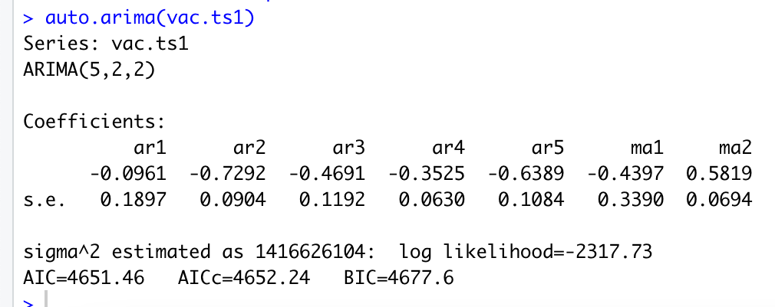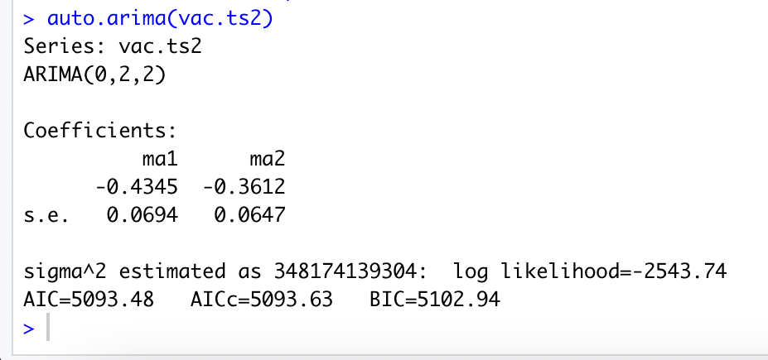

Exhibit 3.11 Auto Arima on Canada Exhibit 3.12 Auto Arima on United States

Now, we have the best models for each country. We have the ARIMA(5,2,2) model for Canada while the United States has a model of ARIMA (0,2,2). The Canada model has coefficients of Φ₁ = -0.0961, Φ₂ = -0.7292, Φ₃ = -0.4691, Φ₄ = -0.3525, Φ₅ = -0.6389, θ₁= -0.4397, and θ₂= 0.5819, while the United States has coefficients θ₁= -0.4345, and θ₂= -0.3612.

From the test done above, we discovered that the value of d is equal to 2. This suggests that if we apply the difference operator twice (∇²Y_{t}) using the adf.test, we may get a stationary p-value. The result can be shown below.

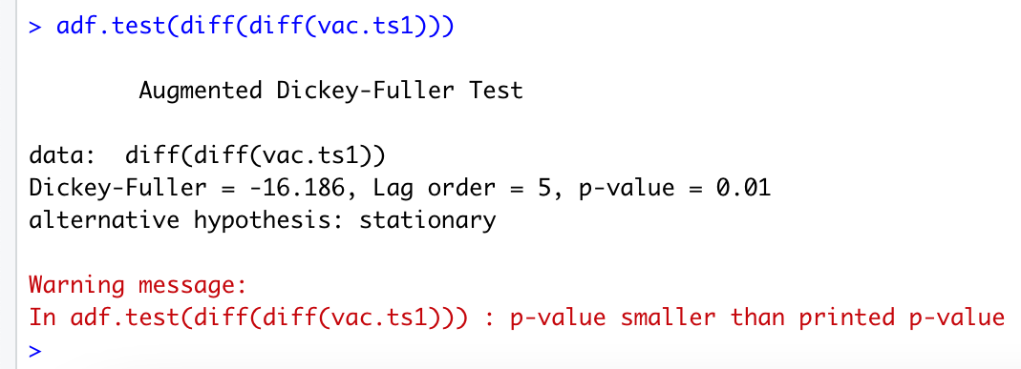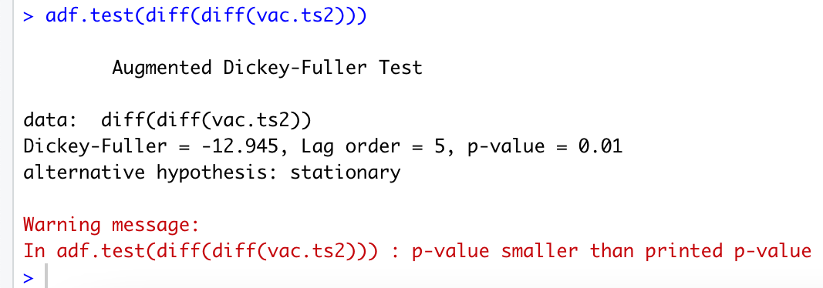

Exhibit 3.13 adf.test (twice) on Canada Exhibit 3.14 adf.test (twice) on the United
States

3.5) Model Diagnostics

Model diagnostics is the very last step before generating the forecasts. We need to make sure that the residuals of the fitted model follow these assumptions:

- The error terms {ε_{t}}are assumed to be a white noise process with mean 0 and constant variance σ² .
- {ε_{t}} are normally distributed.

So, few diagnostics must be done to the residuals such as the standardized residuals plot, acf (for residual) plot, pacf (for residual) plot, and the Q-Q plot.
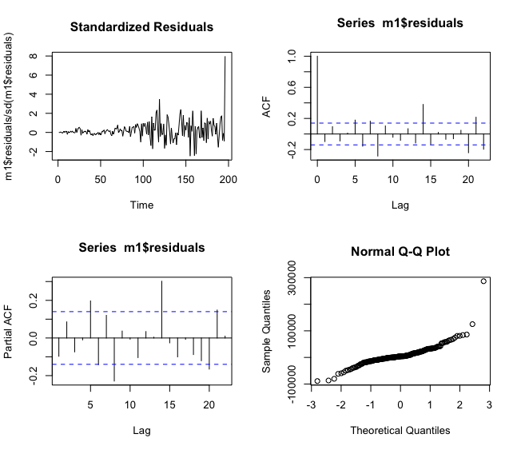

Exhibit 3.15 Standardized Residuals plot, ACF plot, PACF plot, & Q-Q plot on Canada

The exhibit above shows that there is a “volatility clustering” pattern shown on the standardized residuals plot where the point towards the end has a weird point shift approaching the maximum. The ACF and PACF plots almost reflect the ideal case where there’s not really “exponential decay” or any weird pattern can be seen, while the Q-Q plot has a roughly straight diagonal line which is almost ideal except for the one-point outlier at the very top right of the graph. The only way to diagnose the standardized residuals plot is to use ARCH-type models. This assumption, however, may not be valid as we don’t have enough observations for the model so the standardized residuals plot could actually be a normal plot.

Let’s look at the United States’ model diagnostics.

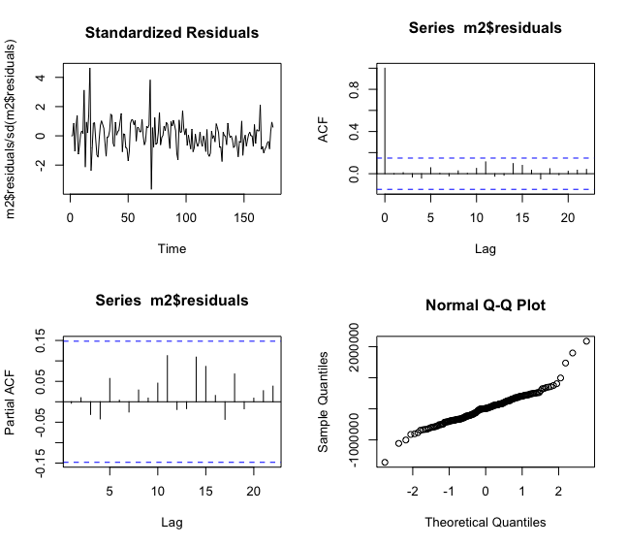
Exhibit 3.16 Standardized Residuals plot, ACF plot, PACF plot, & Q-Q plot on United States

Nothing abnormal can be seen here, except for the standardized residual plot. Again, we can never really tell due to the lack of the number of observations. Nevertheless, if we do an additional unit-root test on both models, just as we did below, we can see that both residuals’ models are stationary and normally distributed.

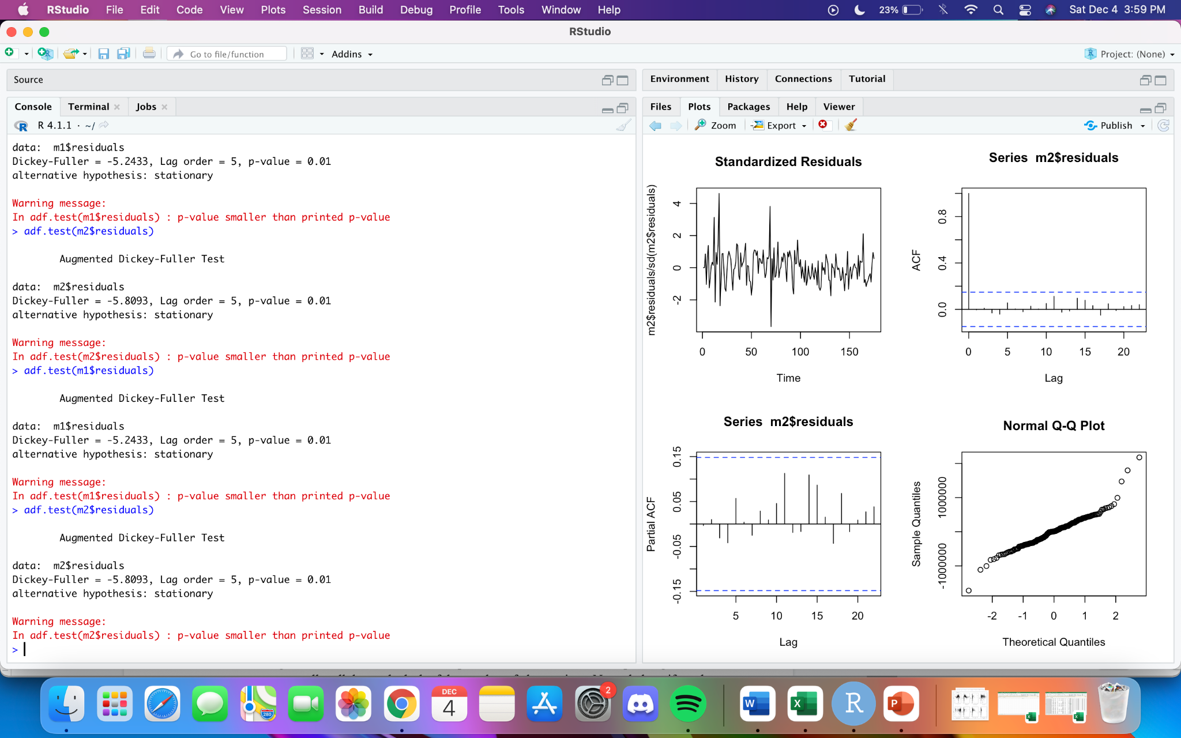

Exhibit 3.17 adf.test done on residuals of Canada and the United States plots

Thus, we can finally move on to the last section, forecasting.

3.6) Forecast

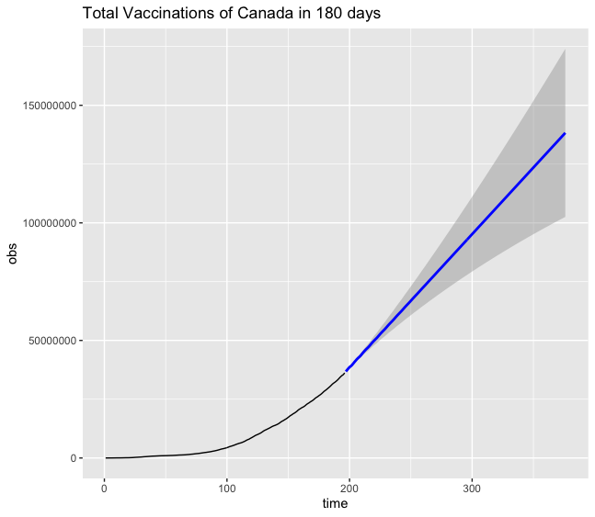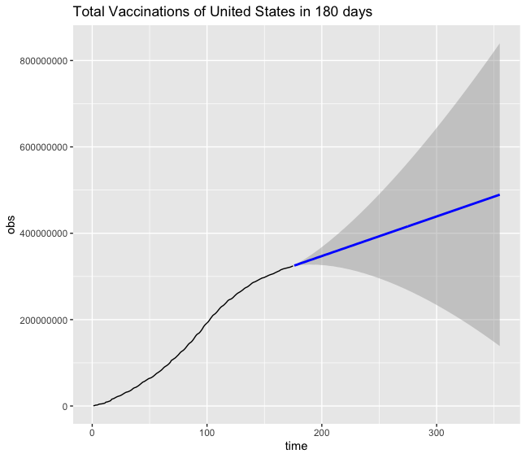
Exhibit 3.18 Forecast of Total Exhibit 3.19 Forecast of Total Vaccinations
Vaccinations of Canada in 180 days of United States in 180 days

The flow of the forecasts looks stable and progressing well after half a year (mid to end of 2021). The only flaw right now in the model is in the number of total populations. For Canada, their total population is only up to 37,742,157, while the United States has 331,002,647. So, the forecast of more than 300,000,000 and 500,000,000 respectively does not make any sense. Therefore, we consider the logit transformation graphs by putting the total populations as the upper bound, as shown in the next two exhibits.
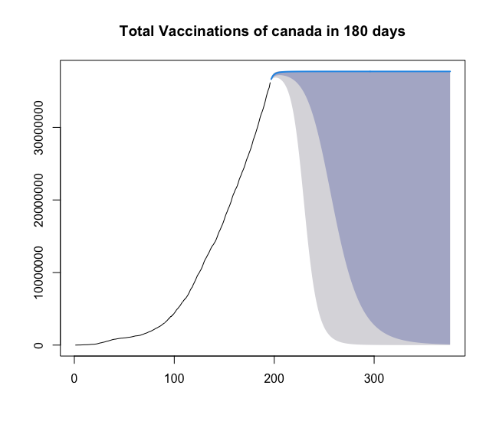
Exhibit 3.20 Logit Forecast of Canada in 180 days

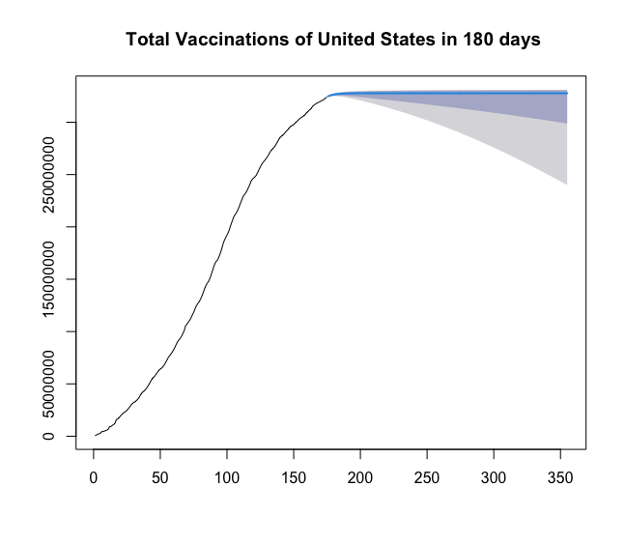
Exhibit 3.21 Logit Forecast of United States in 180 days

Now, the forecast can be seen very clearly. Both countries are predicted to reach the total vaccinations as par with their total populations soon in the next 10 observations. It is the same as a week and a half (10 days) after the last records in the file given. Few errors in the lower half of the confidence interval as the forecast shouldn’t go down which is in the gray area, but the blue line (the estimated forecast prediction) is correct as it is and didn’t go above the expected total populations of each respective country.

Comparison between Regression and Time Series model

In the final regression model, we couldn’t include date as the predictor variable as it was not significant enough. So, if we intend to use the regression model to forecast the future, we need to do so by using other variables that reflect the future date. Because of this, the time series model will be the better choice if we want to forecast the number of vaccinations based on seasonality and time patterns whereas the regression model is useful when we have data on the other variables.
The model diagnostics part of the residuals in both regression and time series model differs as the Q-Q plot of the regression model has a curve pattern in the middle while the time series model for both the United States and Canada are in a straight-line path so the residuals are only normally distributed in the time series model.
Lastly, the comparison that can be made is that both models have obstacles in the beginning of fitting the model where the regression model has several “NA” values in a few rows while the time series model has several 0’s in the early observations. We solve the problem by using stepwise regression in the regression model and separating the unadjusted and adjusted plot observations to the time series model.

Conclusion

The progression rate of the total vaccinations rate varies from one country to another. The predictor variables which highly affected the multiple regression model are the total cases of the virus, the total amount of deaths, the estimated of the reproduction rate of the virus, the number of the ICU patients, the total number of tests done, the amount of the positive rate, the stringency index and the respective countries’ population. Aside from that, the forecast of each country's total vaccinations is looking good and may approach the maximum population soon, based on the time series model that has been stated in this research. We hope that this result can help vaccine frontlines to use the total vaccinations factors to further impact the citizens to take vaccines, and also to hope that the citizens themselves can see from the forecast how close it is to make their country free of the Covid-19 virus.

Appendix

- Appendix A (Regression Model R Code)

# Import data
vac <- read.csv("LOCATION OF NA Vaccinations.csv", header=TRUE)
(ex: "C:/Users/savye/Desktop/New folder (3)/NA Vaccinations.csv")

# Multiple Linear Regression
# R excludes variables with missing values...

fit <- lm(total_vaccinations ~ total_cases + total_deaths + reproduction_rate + icu_patients + hosp_patients + total_tests + positive_rate + stringency_index + population + population_density + median_age + aged_65_older + gdp_per_capita + extreme_poverty + cardiovasc_death_rate + diabetes_prevalence + female_smokers + male_smokers + handwashing_facilities + life_expectancy, data=vac)
summary(fit)

# Stepwise Regression for Variable Selection
library(MASS)
fit <- lm(total_vaccinations ~ total_cases + total_deaths + reproduction_rate + icu_patients + hosp_patients + total_tests + positive_rate + stringency_index + population + population_density + median_age + aged_65_older + gdp_per_capita + extreme_poverty + cardiovasc_death_rate + diabetes_prevalence + female_smokers + male_smokers + handwashing_facilities + life_expectancy, data=vac)
step <- stepAIC(fit, direction="both")
step$anova # Display results

# Final Fitted Model
final_fit <- lm(total_vaccinations ~ total_cases + total_deaths + reproduction_rate + icu_patients + total_tests + positive_rate + stringency_index + population, data=vac)
summary(final_fit)

# Diagnostic Plots
layout(matrix(c(1,2,3,4),2,2)) # View all 4 plots at once
plot(fit)

# Export diagnostic plots
pdf(file = "Diagnostic Plots.pdf") # For convenience - can be jpeg, etc. replace pdf with file type
par(mfrow=c(2,2)) # If included - all plots on one page, if excluded - one plot/page
plot(fit)
dev.off()

#final model
final <- lm(total_vaccinations ~ total_cases + total_deaths + reproduction_rate + icu_patients + total_tests + positive_rate + stringency_index + population, data=vac)

# create a data frame with the new variables
predict <- read.csv("C:/Users/616ja/Documents/unl/ACTS430/predict2.csv", header=TRUE, fileEncoding="UTF-8-BOM")
predict(final, predict)
plot(x=predict(final,predict), y=predict$total_vaccinations,
xlab='Predicted Values',
ylab='Actual Values',
main='Predicted vs. Actual Values')
abline(a=0, b=1)

- Appendix B (Time Series Model R Code)

vac <- read.csv("/Users/allandezman/Documents/Acts 430/Group Project/Total Vaccination.csv", header=TRUE)
# read the total vaccination file

library(forecast)
library(tseries)
library(ggplot2)
library(MASS)
library(dplyr)
# open all the libraries package required for the time series section

vacUnitedStates <- subset(vac, vac$location == "United States")
# subsetting the United States dataset in vacUnitedStates
vacCanada <- subset(vac, vac$location == "Canada")
# subsetting the Canada dataset in vacCanada

vacCanada <- vacCanada %>% arrange((total_vaccinations))
vacUnitedStates <- vacUnitedStates %>% arrange((total_vaccinations))
# rearrange both the total vaccination datasets in each subset in ascending order

##########################################################################################
# Canada Dataset #
##########################################################################################

vac.raw1 <- vacCanada[,11]
# input the total vaccination dataset in a raw vector
vac.ts1 <- ts(vac.raw1)
plot(vac.ts1)
# use the time series function to plot the unadjusted graph

vac.raw1 <- vacCanada[325:520,11]
# reinput the total vaccination dataset vector as the first data of vaccination starts from the 325th data
vac.ts1 <- ts(vac.raw1)
plot(vac.ts1)
# use the time series function to plot the adjusted graph

acf(vac.ts1)
pacf(vac.ts1)
# conduct the acf & pacf function
auto.arima(vac.ts1)
# use the auto arima to select the best model according to AIC value

adf.test(vac.ts1)
# testing for stationarity

adf.test(diff(vac.ts1))
# testing for stationarity, differentiate once

adf.test(diff(diff(vac.ts1)))
# testing for stationarity, differentiate twice

m1 <- arima(vac.ts1,c(5,2,2),include.mean = T)
fitm1 <- fitted(m1)
# fit the model

par(mfrow = c(1,1))
plot(m1$residuals/sd(m1$residuals), main = "Standardized Residuals")
acf(m1$residuals, xlab = "Lag")
pacf(m1$residuals, xlab = "Lag")
qqnorm(m1$residuals)
#residuals and model diagnostics

adf.test(m1$residuals)
#testing for stationarity, for residuals

forem1 <- forecast(m1, 180)
# forecast the data for another 180 days (half a year)

df.obsNfit1 <- data.frame(time = 1:length(vac.ts1),obs = vac.ts1, fit = fitm1)
df.fore1 <- data.frame(time = (length(vac.ts1)+1):(length(vac.ts1)+180), fore = forem1$mean, upper = forem1$upper[,2], lower = forem1$lower[,2])
# convert into data.frame

Fig1 <- ggplot(data=df.obsNfit1,aes(x=time,y=obs))
Fig1
Fig1 + geom_line(col='black') + geom_smooth(aes(x=time, y=fore, ymax=upper, ymin=lower),
colour='blue', data=df.fore1, stat='identity') + ggtitle(paste("Total Vaccinations of Canada in 180 days"))

# figure 1: Canada plot

a <- 0
b <- 37742157
#upper bounds and lower bounds
y <- log((vac.raw1-a)/(b-vac.raw1))
fit1 <- ets(y)
fc <- forecast(fit1, h=180)
#transform data
fc$mean <- (b-a)*exp(fc$mean)/(1+exp(fc$mean)) + a
fc$lower <- (b-a)*exp(fc$lower)/(1+exp(fc$lower)) + a
fc$upper <- (b-a)*exp(fc$upper)/(1+exp(fc$upper)) + a
fc$x <- vac.raw1
plot(fc, main = "Total Vaccinations of canada in 180 days")
# Back-transform forecasts

##logit transformation

##########################################################################################
# United States Dataset #
##########################################################################################

vac.raw2 <- vacUnitedStates[,11]
# input the total vaccination dataset in a raw vector
vac.ts2 <- ts(vac.raw2)
options(scipen=999)
plot(vac.ts2)
# use the time series function to plot the unadjusted graph

vac.raw2 <- vacUnitedStates[350:524,11]
# reinput the total vaccination dataset vector as the first data of vaccination starts from the 350th data
vac.ts2 <- ts(vac.raw2)
plot(vac.ts2)
# use the time series function to plot the adjusted graph

acf(vac.ts2)
pacf(vac.ts2)
# conduct the acf & pacf function
auto.arima(vac.ts2)
# use the auto arima to select the best model according to AIC value

adf.test(vac.ts2)
#testing for stationarity

adf.test(diff(vac.ts2))
# testing for stationarity, differentiate once

adf.test(diff(diff(vac.ts2)))
# testing for stationarity, differentiate twice

m2 <- arima(vac.ts2,c(3,2,5),include.mean = T)
fitm2 <- fitted(m2)
# fit the model

par(mfrow = c(2,2))
plot(m2$residuals/sd(m2$residuals), main = "Standardized Residuals")
acf(m2$residuals, xlab = "Lag")
pacf(m2$residuals, xlab = "Lag")
qqnorm(m2$residuals)
#residuals and model diagnostics

adf.test(m2$residuals)
#testing for residuals

forem2 <- forecast(m2, 180)
# forecast the data for another 365 days (1 year)

df.obsNfit2 <- data.frame(time = 1:length(vac.ts2),obs = vac.ts2, fit = fitm2)
df.fore2 <- data.frame(time = (length(vac.ts2)+1):(length(vac.ts2)+180), fore = forem2$mean, upper = forem2$upper[,2], lower = forem2$lower[,2])
# convert into data.frame

Fig2 <- ggplot(data=df.obsNfit2,aes(x=time,y=obs))
Fig2
Fig2 + geom_line(col='black') + geom_smooth(aes(x=time, y=fore, ymax=upper, ymin=lower),
colour='blue', data=df.fore2, stat='identity') + ggtitle(paste("Total Vaccinations of United States in 180 days"))
# figure 2: United States plot

a <- 0
b <- 331002647
#upper bounds and lower bounds
y <- log((vac.raw2-a)/(b-vac.raw2))
fit1 <- ets(y)
fc <- forecast(fit1, h=180)
#transform data
fc$mean <- (b-a)*exp(fc$mean)/(1+exp(fc$mean)) + a
fc$lower <- (b-a)*exp(fc$lower)/(1+exp(fc$lower)) + a
fc$upper <- (b-a)*exp(fc$upper)/(1+exp(fc$upper)) + a
fc$x <- vac.raw2
plot(fc, main = "Total Vaccinations of United States in 180 days")
# Back-transform forecasts

##Logit transformation

